MSEC EMPLOYER OF CHOICE AWARDS

Terms and Conditions of Entry:
- There are Three CATEGORIES: Up to 50 Employees; 50-150 Employees; 151+ Employees
- Each year, Employers who were recognized as the winning employers at the JSEC level are eligible to be nominated for the MSEC Award. Only JSECs who have a local Employer Award program are eligible to nominate to MSEC.
- The MSEC Nomination form must be completed and submitted to the State MSEC Coordinator by April 1 of each year. Late entries will not be accepted.
- The Nomination form and submittal instructions may be found on the MSEC website at http://wsd.dli.mt.gov/employers/montana-state-employers-council/awards, or on the attached Nomination Form.
- Entries and supporting materials will not be returned to entrants.

Entry Process and Judging:
- Entries will be judged by an independent panel.
- The judging panel will select the Employer of Choice Award winners based on nominations submitted by the April 1st deadline.
- The MSEC Employer of Choice winners will be announced by May 1st.
- Members of the judging panel are ineligible to enter or be nominated.

Assistance in Completing the Entry:
- If you require any assistance in completing your entry, please do not hesitate to contact your local JSEC Coordinator. Contact information and nomination materials may be found on the MSEC website at http://wsd.dli.mt.gov/employers/montana-state-employers-council/awards. Or you may contact Deborah Gass at dgass@mt.gov or 406.218.7488.

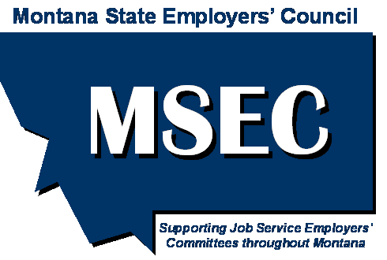 | Montana State Employers’ Council (MSEC)  Employer of Choice Award Nomination Form
The Montana State Employers’ Council (MSEC) would like to recognize businesses that create great workplaces in our State by presenting them with the Employer of Choice award. MSEC will recognize three employers; an employer with up to 50 employees; 51-150 employees; and with 151+ employees.
Each year, winning employers at the JSEC level are eligible to be nominated for the MSEC Employer of Choice Award. The form below must be completed by the local JSECs on behalf of their winning businesses and submitted to MSEC no later than April 1 of each year.

Business Information
Company:
Address:
City: |  |  | Zip:
Phone: |  |  | Email:
Corporate website address:
Size of business: up to 50 employees 51-150 151+ employees
Number of employees:
How long has nominated employer been in business:
Nominated by
Name:
Title:
Phone: |  |  | Email:

- Describe: Employee Benefits/Initiatives (Maximum score=10 points)
1000 Character Maximum

- Describe: Leadership and Workplace Culture (Maximum score=10 points)
Note: Leadership refers to many aspects of a business’ performance, such as effectively communicating with employees, cultivating respect and confidence among employees, leading the way within an industry or community, having vision and being innovative. Workplace Culture refers to the prevalent atmosphere of a business including collaborating with employees in business decisions, respecting life/work balance, demonstrating balanced treatment in personnel decision making and creating opportunities for employees to be recognized.
1000 Character Maximum

- Describe: Employee Training/Development (Maximum Score=10 points)
Note: Employee Development refers to the investment in time and resources a business dedicates to developing its employees including continuing education opportunities, mentoring programs and opportunities for advancement.
1000 Character Maximum

- Describe: Community Orientation (Maximum Score=10 points)
Note: Community Orientation refers to services or contributions a business makes to the community through special programs or outreach. Including developing/providing incentive programs to recycle or use public transportation, sponsoring local events, donating resources to non-profit organizations.
1000 Character Maximum

- Describe: OJT, Mentorship, Internship, or Apprenticeship Opportunities (Tie Breaking Points up to 10 points
Note: Montana is continuing to focus on opportunities to fill the workforce pipeline. What is your organization doing to promote and create opportunities hat build the workforce within the state?
1000 Character Maximum

- Describe: Summary of your Organization
Note: If your organization is selected as the MSEC Employer of Choice, what do you want others to know about your organization?
1000 Character Maximum

Nominations are due on or before April 1st of each year.
Please email completed form to: MSEC gmail account at
MTMSEC41@gmail.com

