MONTANA EMPLOYER ACCESS: EMPLOYER GUIDE
This guide explains how to create an account, add an employer profile, and post a job. Use the new Okta-based site for all new employer profiles and job postings. Follow the instructions below to create an account, add an employer profile, and post a job.
Use | Link
New/current site | Open Montana Employer Access  Use this site for the new account, employer, and job-posting process.
Legacy site | Open the previous USNLx employer login  Use only when WSD transition instructions direct you to access the old system.
Transition note: Existing jobs in the legacy system do not need to be entered again. During transition, the old system will remain available for existing jobs (to view or delete) while all new postings move to the new site.

Before you begin
Have the following information ready:
- An individual, monitored email address and the account holder's first and last name.
- The employer's legal/company name, FEIN, NAICS classification, physical address, and contact information.
- Job details, including locations, schedule, hours, number of openings, job description, and application method.
Email matters: Approval and status messages are routed to the account/login email (the poster), not necessarily the Contact Email entered on the employer profile. Use an inbox that the person managing postings checks regularly.

1. Create or access your account
- Open Montana Employer Access at post.montana.usnlx.com. The page redirects to the DirectEmployers sign-in screen.
- If you already have a DirectEmployers/Recruit Rooster SSO account, enter your email and select Next. If you do not have an account, select Sign up.
- On the Sign up screen, enter your email address, first name, and last name, then select Sign Up.
- Check the email you entered for a message from DirectEmployers Accounts. Complete the one-time verification or activation steps in that message, then return to Montana Employer Access and sign in.
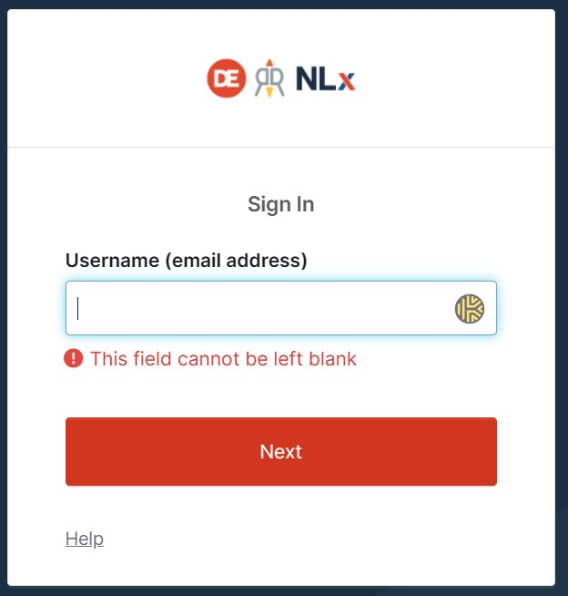
Figure 1. The DirectEmployers sign-in screen.
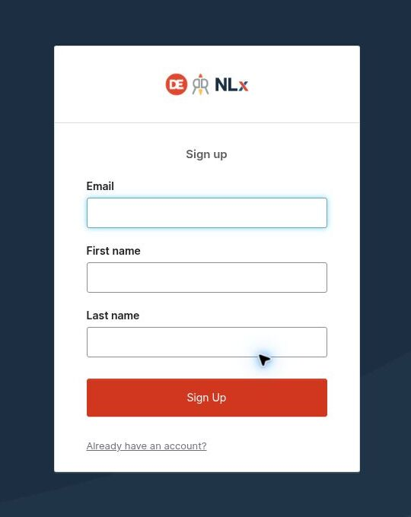
Figure 2. Select Sign up and enter an email, first name, and last name.
Named account recommended: Use the individual who will manage the postings. The platform records that person as the poster and sends workflow messages to the login email.

2. Add an employer profile
- After your first sign-in, select Get Started on the welcome screen. Returning users can open Employers and select Add Employer Profile.
- Enter the employer information. Fields marked with an asterisk are required. Verify the company name carefully because it cannot be changed after the profile is created.
- Select Submit. The employer profile is created with a Pending status and is placed in the staff review queue.
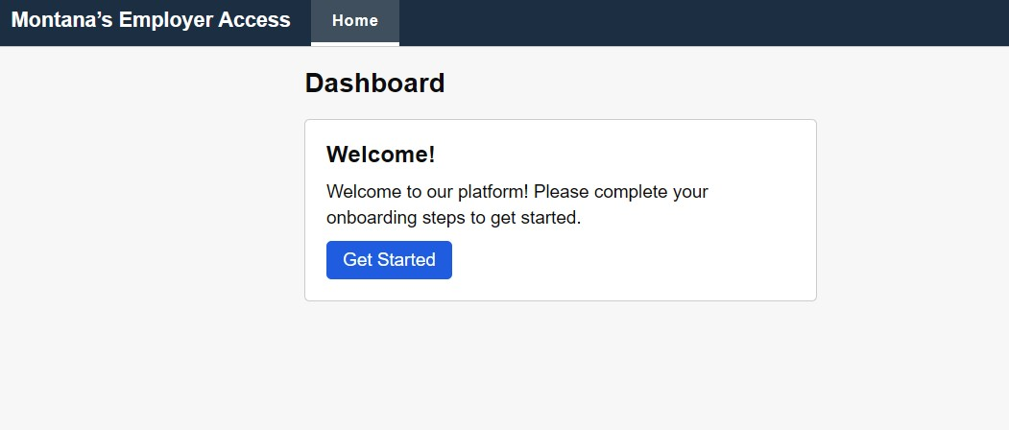
Figure 3. First-time users select Get Started to begin the onboarding process.

Required employer information
Field | What to enter
Name | Employer/company name. Check spelling before submission; the name cannot be changed later.
FEIN | Federal Employer Identification Number.
NAICS | North American Industry Classification System code/category.
Federal Contractor | Select Yes or No.
State / Province | Select Montana or the employer's applicable state/province.
Address | Employer Address Line 1, City, and Postal Code.
Contact Email | Email for the employer's point of contact.
Contact Name | Name of the employer's point of contact.

Optional fields include website address, SEIN, industry, company description, Address Line 2, contact phone, and contact job title.
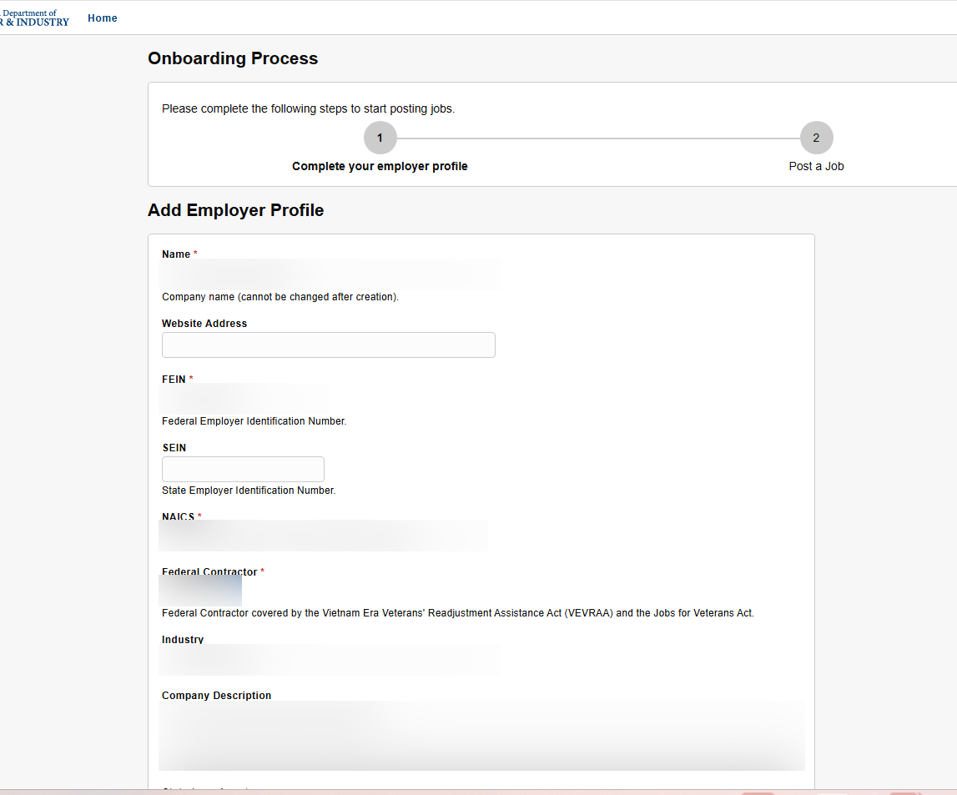
Figure 4. Employer profile, upper portion. Entered values are redacted.
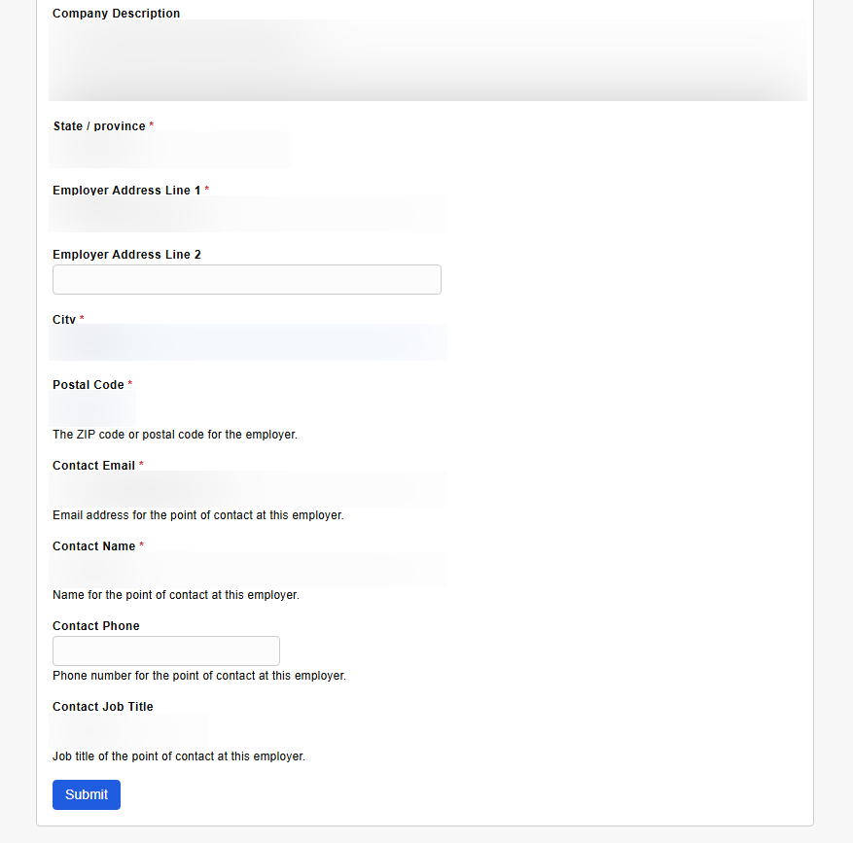
Figure 5. Employer profile, address and contact fields. Entered values are redacted.
Multiple employers: One user account can manage more than one employer profile. Use Employers > Add Employer Profile for each additional organization.

3. Create a job posting
- Open the employer profile and select Create Job. You may prepare a job posting while the employer profile is Pending, but it cannot be approved or published until the employer profile is approved.
- Complete the Job Posting Options and Job Description sections. Fields marked with an asterisk are required.
- Review the information, then choose Save as Draft or Submit for Review.

Required job information
Field | What to enter
Employer | Select the employer associated with the job.
Days Visible | Enter the posting duration within the maximum displayed on the form.
Job Title | Title as it should appear to job seekers.
Requisition ID | The employer's identifier for the job.
Job Locations | Select one or more cities. A location is required even for remote jobs.
Hours / Positions | Hours per week and number of positions.
Place of Work | On-site, Remote, or Hybrid.
Job Description | Duties, qualifications, and other relevant information.
How to Apply | Choose Link, Email, or Instructions and complete the corresponding field.

- If you enter compensation, confirm that Salary Type (for example, hourly or yearly) matches the amounts.
- Use the registered-apprenticeship checkbox when applicable.
- Optional details include experience, education, licenses, training, expected start date, compensation, job type, and shift.
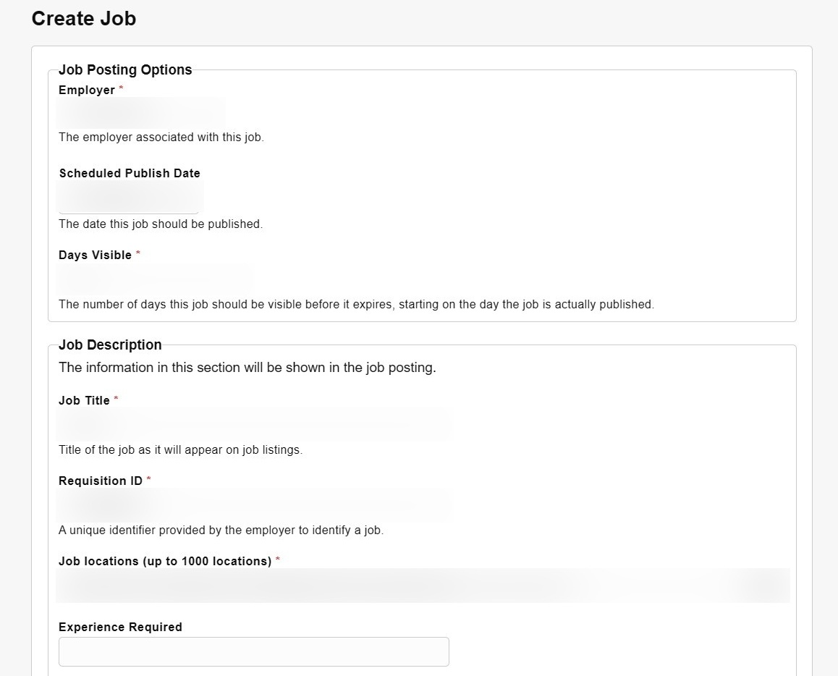
Figure 6. Job posting options and the first portion of the job description form. Entered values are redacted.

Complete the remaining job fields
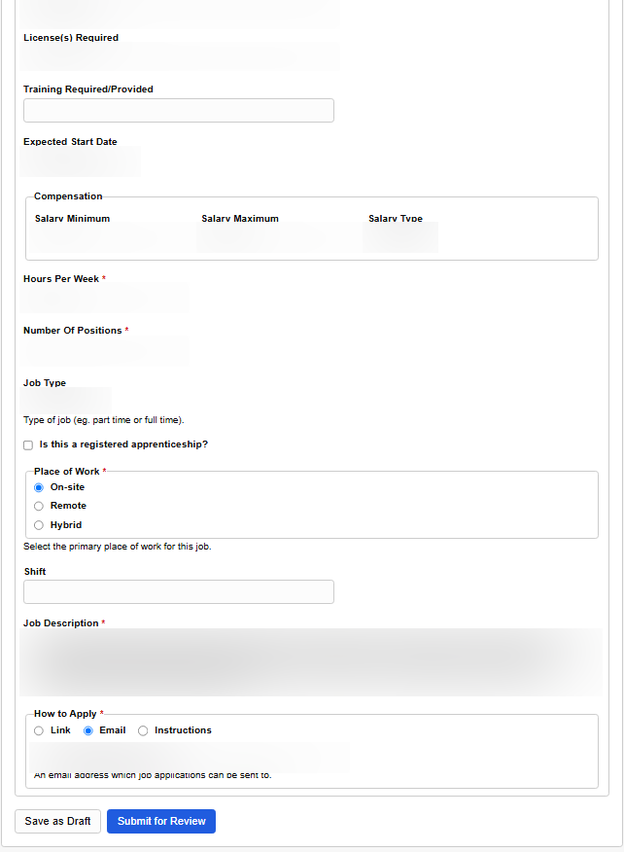
Figure 7. Compensation, apprenticeship, place-of-work, description, and application fields. Entered values are redacted.
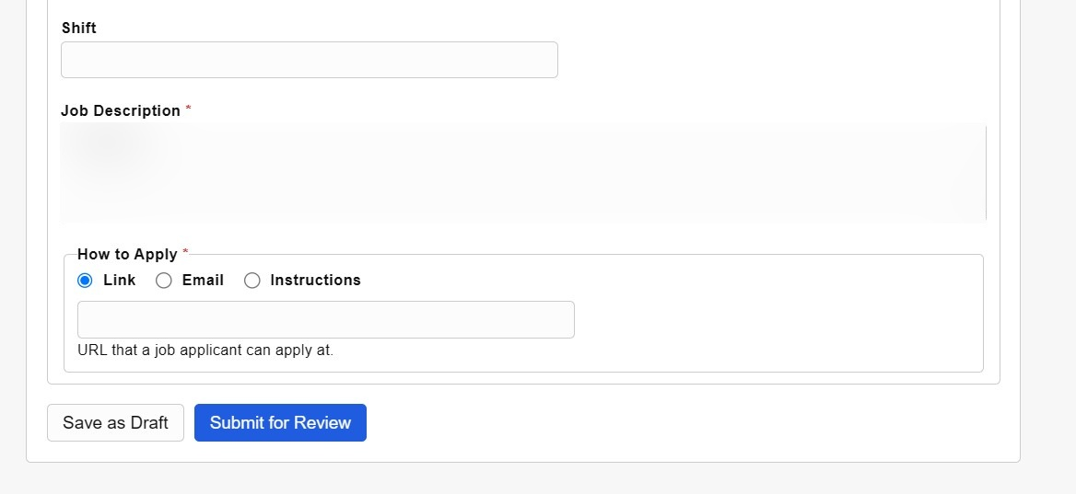
Figure 8. Save the posting as a draft or submit it for staff review. Entered values are redacted.

Save as Draft or Submit for Review?
Choice | Result
Save as Draft | Stores the posting without placing it in the staff approval queue. The publication status remains Draft.
Submit for Review | Places the posting in Job Received status. It remains Not Published until the required approvals are complete and the scheduled publish date is reached.

4. After you submit
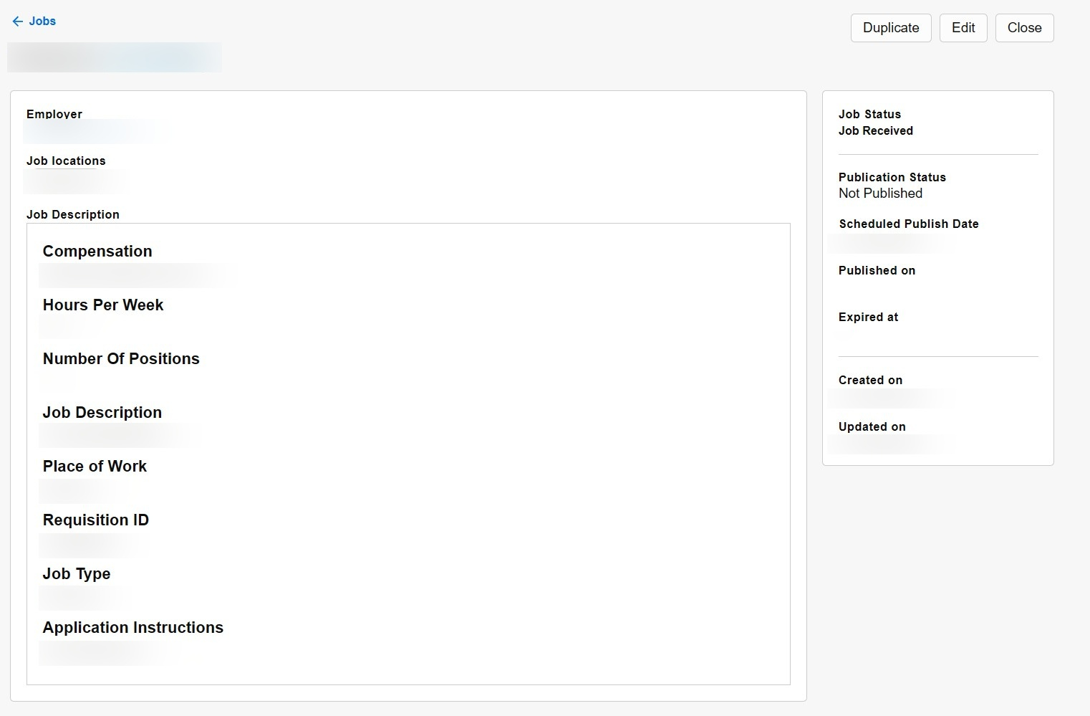
Figure 9. A submitted posting shows Job Received and Not Published while it awaits review.
- Staff will review the employer profile before approving its jobs.
- Watch the account/login email for approval messages or a request for more information.
- If information is requested, open the employer or job, make the correction, and return it for review as directed.
- An approved job publishes on or after its scheduled publish date. When approved on that date, it normally appears within a few minutes.

Common job statuses
State | What it means
Draft | Saved but not submitted for review.
Job Received | Submitted and awaiting staff action.
Pending/Held | Staff needs additional review or information, or a previously reviewed job was edited.
Approved | Approved for publication when the scheduled date is reached.
Rejected | Not approved; the posting is closed. You can use Duplicate to create a corrected replacement when appropriate.
Open / Scheduled / Closed | Publication states showing whether the approved posting is currently visible, waiting for its date, or no longer active.

Manage existing postings
Use the Jobs tab or the employer profile to open a posting. Depending on its status, you may be able to:
- Edit the posting. Editing a reviewed job normally returns it to Pending/Held unless the employer has auto-approval.
- Duplicate the posting to create a new posting from the existing information. Review the copied requisition ID and all dates before submitting.
- Close a posting that should no longer be active.
Get help
Email: DLIWSDcustomersupport@mt.gov
Local assistance: Find a Job Service Montana office

