Regional WIOA Adult Education Providers
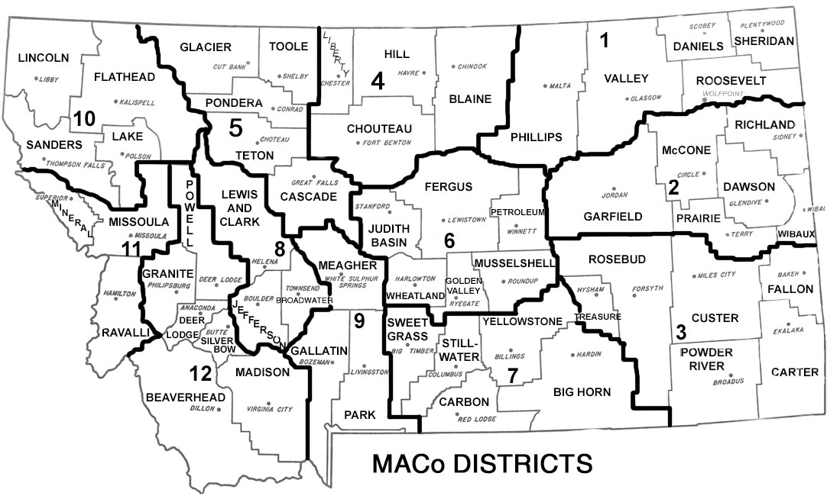
MACO 1 & 2 | MACO 3 | MACO 4
Glendive  Dawson Community College  406-377-9448 | Miles City  Miles City Community College  406-874-6152 | No provider currently serving the area. For assistance please reach out to Jacqueline.Wroble@mt.gov
MACO 5 | MACO 6 | MACO 7
Great Falls  College and Career Readiness Center 406-771-5108 | Lewistown  HRDC District 6  406-535-7488 | Billings  Lincoln Center  406-281-5055
MACO 8 | MACO 9 | MACO 10
Helena  Adult Learning Center  406-447-6387 | Livingston  One Health  406-823-6363 | Kalispell  Flathead Valley Comm College  406-756-3884
MACO 11 | MACO 12 | Dept of Corrections
Missoula  Lifelong Learning Center  406-549-8765 | Butte  Webster Complex  406-533-2967 | No provider currently serving the area. For assistance please reach out to Jacqueline.Wroble@mt.gov


