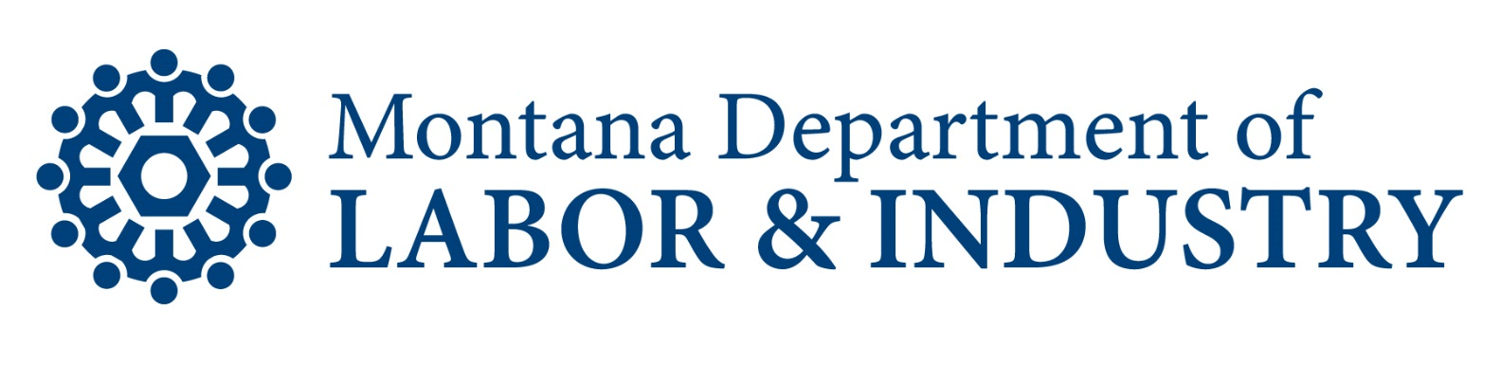
Division: Workforce Services Division
Category: Programs
Effective Date: 10/1/2021
Last Revised: 10/1/2021
Policy No.: 04-16

Health and Economic Livelihood Partnership (HELP) Link

Policy – Diversion Assistance
Background
HELP-Link Diversion Assistance offers HELP-Link eligible clients one-time, short-term financial assistance. Diversion Assistance is not appropriate for clients currently enrolled in HELP-Link services.
Scope
This policy applies to all MTDLI HELP-Link contractors and MTDLI Central Office staff. This policy is effective October 1, 2021.

Policy
- Diversion Assistance is limited to payments for goods and services necessary for the HELP-Link eligible client to obtain or maintain employment.
- A diversion assistance application must be completed prior to making the payment. The application must reflect the need for assistance and the amount of such assistance based on the results of a financial assessment.
- Payment(s) may not exceed $250, per client per state fiscal year.
- Diversion assistance payments must be:
  - paid directly to a vendor (all vendors must be willing and able to submit a W-9 form to receive payment)
  - for one-time expenses - payments are not intended for ongoing expenses
  - allowable per the HELP-Link supportive service policy and follow all applicable policy for the payment type

Administrative Requirements
- Feedback to and from both DPHHS and MTDLI to communicate client involvement in HELP-Link and services provided.
- Provide data and information to legislative subcommittees regarding program participation, expenditures, and outcomes.
- Provide data and reports to DPHHS as needed.

Oversight and Evaluation
- Oversight and evaluation will be conducted by the Program Manager and/or designee(s).

References
- 2015 Montana Legislature Senate Bill 405
- 2019 Montana Legislature House Bill 658
- 2021 Montana Legislature House Bill 614
- Montana Code Annotated (MCA), 39-12

